LS2X Barcode Label Scale Zero-Full Weight Learning Method
1 Destroy the sealing
- Destroy the fragile label sealing of switch stator;
- Unscrew bolts;
- Open switch stator;
- When the scale is charged with electricity, move the switch to the other side or use the metal project short peg , and move it to the original position , then close the switch stator.
- What you need to do is breaking the label on the above adjustment and do not need to open case to destroy the sealing. Please take the below pictures as your references:
Picture name: nut sealing and fragile label sealing Fragile
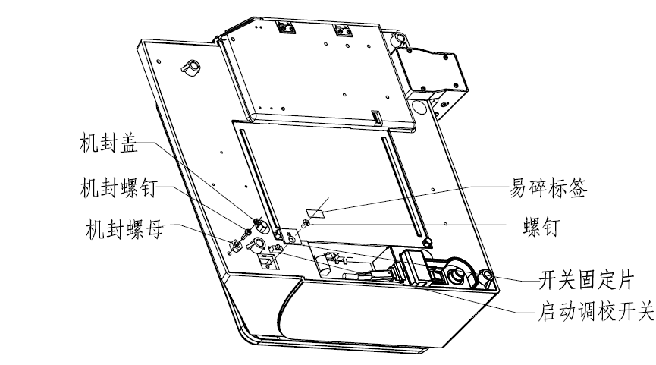
Fragile label
Screw
Switch stator
Use adjustment switch
Sealing cover
Sealing screw
Sealing nut

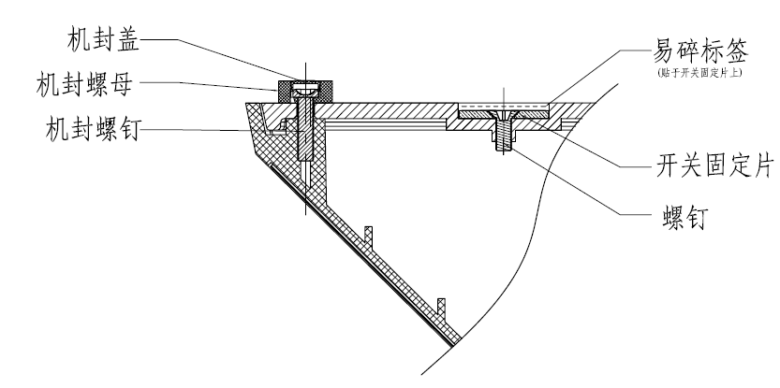
Fragile label
Switch stator
Screw
Sealing cover
Sealing screw
Sealing nut

2. Enter factory mode
Turn on the scale, while the display counts down from ‘9’ to ‘0’, press [C] key to enter factory mode. Press [System Set] key,
3. Zero/full weight learning:
After entering factory mode, when “ZERO” is prompted on display, be sure now there is no any things on the tray, then press [Enter] to make the first line of the display shows 0.
When “FULL” is prompted on display, put on 15kg poise, then press [Enter] to make the first line of the display shows 15kg.
4. Exit from calibration:
To exit the factory mode, please press [C], and then press [On/Off] for 2-3 seconds to return the normal operation.

